Lodging Itinerary
Air  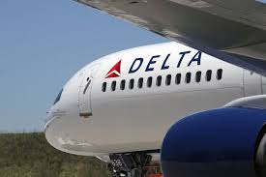 | Delta Airlines (DL)  SLC (Salt Lake City ) to CDG (Paris)  Non stop/round trip  April 6th  SLC 4:53 p.m.  CDG 11:15 a.m.  April 16th  CDG 10:35 a.m.  SLC 4:13 p.m.  $1811.00
Hotel  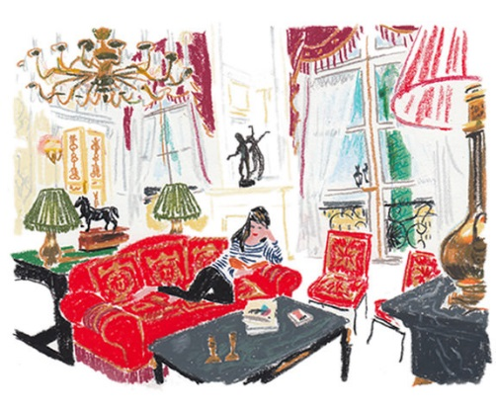 | Ritz Carlton--Paris  Location:  Paris France  +33 (0)1 43 16 30 30  $750 per night
Day 1 – April 6  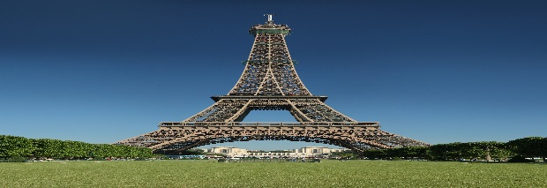 | Paris France  9:00 a.m. Breakfast at Hotel  10:30 a.m. Walk around Paris  12:30 p.m. Lunch at a cafe  1:00 p.m. Louvre  $30  6:30 p.m. Eiffel Tower at Night  $18  Walk around Paris at night
Day 2 – April 7  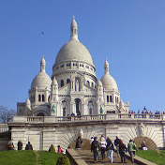 | Sacre’Coeur  10:00 a.m. Shop & Eat at Sacre’Coeur

Day 3 – April 8  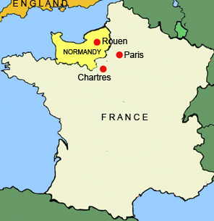 | Normandy D-Day and Beaches Tour  Location:  5700 East McDonald Drive  Scottsdale, AZ 85253  $200.00  7:00 a.m. Leave for Tour  9:00 p.m. Return from Tour
Day 4 – April 9  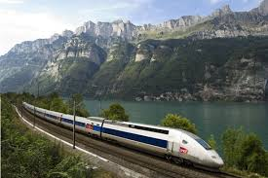 | Rail Europe  Paris to Amsterdam  8:16 – 11:42 Thalys 9315 Second Class $235  12:30 Check in to Hotel  Waldorf Astoria  $757 per night  King Loft Bed & Breakfast  4:00 Sandalmans Amsterdam Tour $13
Day 5 – April 10  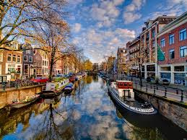 | Day in Amsterdam  Walk around Amsterdam and eat and fun cafes and enjoy the scenery
Day 6 – April 11  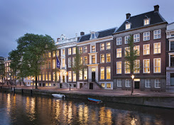 | Rail Europe  Amsterdam to Paris  8:16 – 11:42 Thalys 9322 First Class  (lounge, business class, wifi)  2:00 Tour Paris (Notre Dame, Arc de Triumph, Musee D’orsay, Bateaux Mouche,)  6:00 Dinner  8:30 Evening Concert

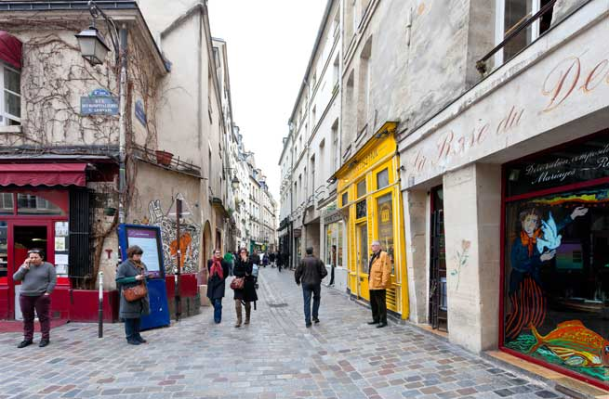  Day 7 – April 12 | Shopping in Paris  10:00 Shopping in Marais  1:00 Rue Des Martyrs  3:00 Chocolate Crawl in  Saint Germain-Des-Pres  7:00 Dinner at L’Arpege
Day 8 – April 13  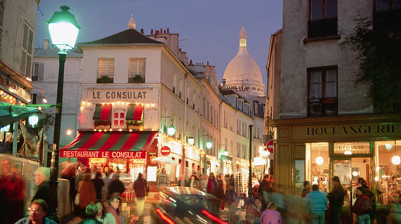 | The Louvre  10:00 Tour the Louvre $30  5:00 Montmartre Walk & Dinner
Day 9 – April 14 | EuropeCar Rental Car  38 Avenue Des Ternes  $25 per day  Convertible  Drive the Country Side of France
Day 10 – April 15 | Last Day in Paris  10:00 Shop and Eat and Walk Around to favorite places.
Day 11 – April 16 | Leave Paris  CDG 10:35 a.m.  SLC 4:13 p.m.  Air $1800  Hotel $7570  Rail/Car $ 260  Activities $ 726  Food $1000  Total Cost of Trip $10,856

