HOSPITALITY & TOURISM
Product Life Cycle
Standard 1 Objective 2
Explain the product life cycle.

Assignment

- Name and describe an amazing travel invention.

- Label the product life cycle for an amazing travel invention.
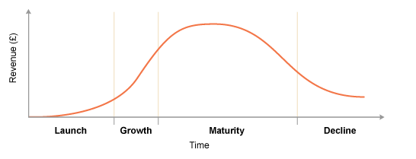

- Identify the stage in the product life cycle the invention is most likely in (explain).

