Lodging Itinerary
Hotel Bed and Breakfast  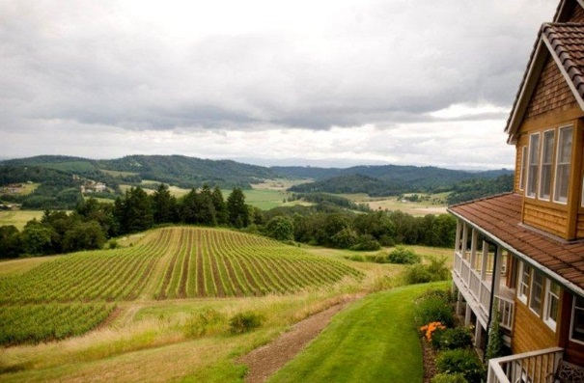 | Youngberg Hill Vineyard – McMinnville Oregon  Location:  10660 Youngberg Hill Road , McMinnville, OR 97128 US  Guest Type:  Leisure  Price:  Mid Scale  $220 nightly  Style & Function:  Bed and Breakfast
Hotel Spa  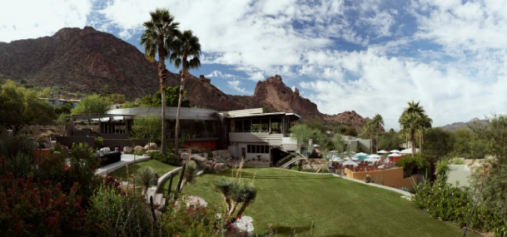 | Sanctuary Camelback Mountain Resort and Spa – Scottsdale Arizona  Location:  5700 East McDonald Drive  Scottsdale, AZ 85253  Guest Type:  Leisure  Price:  UpScale  $650 nightly  Style & Function:  Spa and Vacation
Hotel Extended Stay | Residence Inn Airport– Salt Lake City Utah  Location:  4883 West Douglas Corrigan Way Salt Lake City, UT 84116  Guest Type:  Business  Price:  Economy  $160 nightly  Style & Function:  Extended Stay

