Three Day Salt Lake City Vacation
Hotel  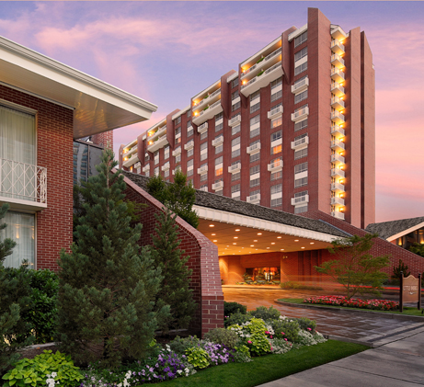 | The Little America Hotel - Salt Lake City  500 South Main Street  Salt Lake City, Utah 84101  Telephone: 801-596-5700  - Superior Tower 2 Double Beds  - $149.00 per night (4 nights)  - $15.00 Breakfast Buffet  - Swimming Pool  - Exercise Room  Hotel: $600.00  Gas: $200.00  Parking: $40
Day 1 Thursday, March 14th  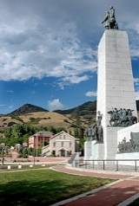 | 8:00 a.m. Breakfast at Lambs Grill  10:00 a.m. Hike Ensign Peak  11:00 a.m. Drive Through Gravity Hill  11:30 a.m. Visit Brigham Young’s Grave  12:00 noon Lunch at Litza Pizza  1:00 noon Visit “This Is The Place State Park”  3:00 p.m. Joseph Smith Memorial Building  (watch movies and temple square)  6:00 p.m. Dinner at Joseph Smith Building  8:00 p.m. Mormon Tabernacle Choir Prac.  Food: $340 Entertainment: $25
Day 2 Friday, March 15th  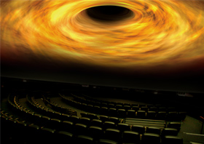 | 9:00 a.m. Breakfast and Bruges Waffles  (336 W. Broadway (300 S.)  10:00 a.m. Family History & Church Museum  11:30 p.m. Lunch at Blue Iguana  1:00 p.m. Clark Planitarium  3:00 p.m. City Creek  5:30 p.m. Dinner at The Melting Pot  8:00 p.m. Movie at Gateway  Food: $280 Entertainment: $50.00
Day 3 Saturday, March 16th  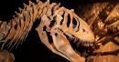 | 8:30 a.m. Breakfast at Little America  10:00 a.m. Natural History Museum  12:30 p.m. Lunch at Crown Burgers  2:00 p.m. Granite Mountain Records Vault  4:00 p.m. Jazz Game vs. Grizzlies  Food: $180.00 Entertainment: $298
 | Total Cost: $2000

